A Multi-objective ENhanced Tool for Optimal meal Recommendation system: MENTOR applied to elderly care facilities

Introduction

Background
The importance of balanced nutrition has become increasingly recognized as a critical determinant of public health outcomes and quality of life in modern society. This concern is particularly pressing as global demographic shifts toward aging populations have intensified the need for strategic nutritional interventions, with elderly individuals being particularly vulnerable to malnutrition and diet-related chronic diseases[1,2]. Chronic non-communicable diseases—including diabetes, cardiovascular disease, and metabolic syndrome—account for a substantial proportion of global morbidity and mortality, with dietary factors recognized as primary modifiable risk factors[3]. Evidence suggests that precision nutrition strategies can effectively prevent chronic disease onset and progression while promoting longevity and healthy aging[4].
This growing awareness has catalyzed a paradigm shift from population-level dietary guidelines to individualized nutritional recommendations that consider variability in nutritional requirements, chronic disease status, genetic predispositions, cultural preferences, and socioeconomic constraints[5,6]. For instance, personalized nutrition has demonstrated superior efficacy in managing conditions such as type 2 diabetes, where tailored dietary interventions significantly improve glycemic control and metabolic outcomes compared to standardized recommendations. Despite these advances in nutritional science and the clear benefits of personalized approaches, traditional menu planning methods remain inadequate for meeting the complex demands of modern dietary optimization.
Contemporary menu planning practices face substantial challenges that compromise their effectiveness and practical implementation. Traditional approaches rely heavily on manual methods requiring extensive time investment from nutritionists and dietitians, who must manually balance nutritional requirements, cost constraints, seasonal availability, cultural acceptability, and dietary variety—a cognitively demanding task that limits scalability and consistency[7]. Manual planning struggles to simultaneously optimize the multidimensional requirements of modern nutritional adequacy, which encompasses numerous micronutrients, macronutrients, dietary fiber, and bioactive compounds, each with specific recommended intake ranges, often resulting in suboptimal nutritional profiles or infeasible diet plans[8]. Furthermore, economic accessibility remains a critical barrier to nutritious diets, particularly for low-income populations and resource-constrained institutional settings such as elderly care facilities, yet manual planning methods inadequately address the trade-offs between nutritional adequacy and affordability[9,10]. Dietary diversity and sensory variety—essential for long-term dietary adherence and nutritional completeness—are often compromised in manually designed menus[11].
The fundamental challenge lies in the inherent multi-objective nature of diet planning. Nutritional adequacy, cost minimization, dietary diversity, and meal acceptability represent competing objectives that traditional methods cannot systematically optimize[12,13]. The complexity of diet planning—characterized by multidimensional nutritional requirements, discrete food choices, nonlinear interactions between nutrients, and conflicting objectives—creates vast solution spaces that require advanced computational approaches for efficient and effective exploration[14,15].
Computer-based multi-objective optimization offers a transformative solution to these challenges. Such systems provide objectivity by eliminating subjective biases through evidence-based algorithmic decision-making, efficiency through rapid exploration of millions of potential menu combinations, and the capability to simultaneously optimize multiple competing objectives while satisfying complex nutritional and operational constraints. Moreover, computational approaches enable scalability to diverse populations and dietary requirements without proportional increases in human effort, ensure reproducibility through consistent and auditable optimization processes, and generate Pareto-optimal solution sets that reveal inherent trade-offs between objectives, empowering decision-makers with informed choices rather than arbitrary compromises.

Objective
This study develops a Multi-objective ENhanced Tool for Optimal diet Recommendation (MENTOR) that integrates nutritional science principles with state-of-the-art multi-objective evolutionary algorithms (MOEAs). The system employs NSGA-II, NSGA-III, SPEA2, and ε-MOEA to generate optimal meal plans that comply with evidence-based dietary guidelines while ensuring practical implementability in real-world settings.
MENTOR simultaneously optimizes four critical dimensions: (1) nutritional adequacy through penalty-based assessment of deviations from dietary reference intakes, (2) cost efficiency by normalizing meal costs against institutional diet databases, (3) menu harmony based on co-occurrence patterns in historical diet data, and (4) dietary diversity using the Simpson diversity index to ensure variety. The system generates Pareto-optimal solution sets representing optimal trade-offs among these competing objectives, enabling decision-makers to select solutions aligned with specific priorities based on contextual requirements. Practical constraints include ingredient availability, portion size specifications (0.6-1.0 ratio), and meal structure conventions.
Applied to elderly care facility menu planning, this research makes three key contributions. First, it provides a systematic performance comparison of four MOEAs on an identical diet optimization problem, evaluating hypervolume, spacing, diversity, convergence, and computational efficiency to inform algorithm selection. Second, it conducts empirical validation with practicing dietitians at elderly care facilities, comparing MENTOR-generated menus against manually planned menus. Third, it assesses the system's usability through practitioner evaluation, ensuring the tool meets real-world operational requirements.

Related work

Classical Single-Objective Optimization
The systematic application of mathematical optimization to dietary planning originated with George Stigler's 1945 work addressing the "Diet Problem"—identifying minimum-cost food combinations satisfying nutritional requirements for U.S. military personnel[16,17]. Dantzig's simplex algorithm validated Stigler's approach, extablishing the foundational framework for computational diet optimization[18].
Early research concentrated on Linear Programming (LP) with cost minimization as the sole objective while constraining nutritional adequacy to minimum threshold requirements[19]. This approach successfully addressed nutrient deficiency prevention in resource-constrained settings with guaranteed global optimality for convex problems[20].However, single-objective LP suffered from severe practical limitations. Optimization frequently produced monotonous diets with minimal food diversity, as algorithms selected the most cost-efficient nutrient sources regardless of palatability[21,22]. These approaches provided no consideration of taste preferences or dietary patterns, resulting in theoretically optimal but practically unacceptable diets. The limitations led to recognition that diet optimization is inherently multi-objective, involving competing goals that cannot be reduced to a single scalar function without arbitrary weighting decisions.

Multi-objective Optimization and Metaheuristic-Based Approaches
Research began incorporating diverse objectives beyond cost minimization, including nutritional balance optimization, dietary diversity maximization, and personal preference satisfaction [13,23,24]. Initial multi-objective approaches employed weighted-sum methods, ε-constraint optimization, and goal programming. Abejón et al. optimized Spanish diets considering nutritional contribution, greenhouse gas emissions, and cost[25], while Canadian research applied weighted-sum and ε-constraint approaches to design nutritionally adequate, affordable food baskets promoting public health[10]. However, these traditional methods faced computational complexity with exponential growth in problem scale, struggled with mixed discrete-continuous variable, provided limited Pareto front exploration, and introduced weight-dependent subjectivity.
The combinatorial nature of diet optimization—selecting meal combinations from large food databases with mixed discrete-continuous variables and nonlinear nutritional interactions—necessitated metaheuristic solutions[26]. State-of-the-art methodologies employ multi-objective evolutionary algorithms (MOEAs). NSGA-II employs fast non-dominated sorting with crowding distance, demonstrating superior performance in two-to-three objective diet problems[27]. NSGA-III extends NSGA-II for many-objective optimization using reference point-based selection[28]. SPEA2 utilizes strength-based fitness assignment with external archive maintenance for preserving high-quality solutions[29], while ε-MOEA employs the ε-dominance concept for controlled solution distribution and computational efficiency. These MOEAs enable simultaneous pareto front exploration, generating multiple non-dominated solutions that reveal inherent trade-offs between competing objectives. They effectively handle the nonlinear discrete and mixed-variable constraints effectively and scale to large problems involving hundreds of food items and dozens of nutrients without requiring a priori weight specifications.

Application Domain Expansion and Specialized Research
Building on these algorithmic advances, research has expanded to specialized dietary optimization for specific populations and contexts. Modern diet optimization frameworks increasingly integrate multidimensional personalization factors beyond basic nutritional requirements. Individual metabolic characteristics including basal metabolic rate, physical activity levels, and anthropometric measurements inform caloric and macronutrient targets[5]. Disease-specific approaches have applied multi-objective optimization to diabetic patient diets, simultaneously addressing glucose control, nutritional balance, and economic efficiency through evolutionary algorithms[8,15,30]. Disease management considerations for conditions such as diabetes, hypertension, cardiovascular disease, and renal disease require specialized nutrient restrictions and therapeutic dietary modifications[6].
  - 고령 추가

Current Research Limitations and Study Contributions
Despite substantial progress in diet optimization research, several critical gaps remain. First, existing studies predominantly focus on nutritional adequacy, cost, and diversity while neglecting menu compatibility based on historical dietary patterns, which is essential for meal acceptability, particularly in elderly care settings where established food combinations influence dietary intake. Second, insufficient systematic comparison of multiple MOEAs on identical diet optimization problems with standardized performance metrics limits evidence-based algorithm selection in practice. Third, a lack of accessible, user-friendly tools integrating expert nutritional knowledge with advanced optimization algorithms specifically designed for elderly care facilities hinders real-world dietary planning applications.
This study addresses these gaps through three main contributions. First, we develop a comprehensive four-objective optimization framework that incorporates menu harmony based on historical co-occurrence patterns alongside nutrition, cost, and diversity, with specific consideration for elderly dietary needs and preferences. Second, we conduct systematic empirical comparison of four state-of-the-art MOEAs using standardized performance metrics to provide evidence-based algorithm selection guidance for elderly care facility menu planning. Third, we implement MENTOR, a practical optimization tool designed specifically for elderly care facilities that integrates expert nutritional knowledge, realistic operational constraints, and user-friendly interfaces to bridge the gap between algorithmic optimization and real-world dietary planning practice.

Multi-objective Enhanced Tool for Optimal Diet Recommendation

Problem Definition and Formulation
The diet optimization problem represents a complex multi-objective optimization challenge in which multiple competing objectives must be balanced simultaneously. These objectives include nutritional adequacy, cost-effectiveness, menu compatibility, and dietary diversity. While traditional approaches often focus on optimizing a single objective, such as minimizing cost or maximizing nutritional value, our formulation uniquely captures the interdependencies between these objectives through a comprehensive mathematical framework that enables concurrent optimization of all factors.

Objective 1: Nutritional Score
The nutritional score (NS) quantifies how well a diet meets established nutritional requirements over a specified planning period. The evaluation employs a daily penalty-based scoring system where each day starts with a base score of 100, from which deductions are systematically applied for deviations from nutritional guidelines.
Let $N$ denote the set of essential nutrients to be monitored. For each nutrient $n ∈ N$, the lower and upper bounds of recommended daily intake are denoted as $L\left(n\right)$ and $U\left(n\right)$, respectively. The nutrient-specific importance weight is represented by W(n), while $C_{d}\left(n\right)$ indicates the actual nutrient content for day $d$.
The nutritional evaluation process begins with daily nutrient aggregation, where for each day $d$, the total nutrient content is calculated by summing across all three meals (breakfast, lunch, dinner). This aggregation is formalized as:
$$C_{d}\left(n\right)=\sum_{k=1}^{3}{\sum_{m∈M_{k}}{B_{m}\left(n\right)∙r_{m}}}$$where $M_{k}$ represents the set of menus in meal k, $B_{m}\left(n\right)$ is the base nutrient content of menu $m$ for nutrient $n$, and $r_{m}$ is the serving ratio for menu $m$. This formulation accounts for the variable serving sizes that allow flexibility in portion control while maintaining nutritional tracking accuracy.
The daily nutritional score $NS_{d}$ is subsequently calculated using a penalty-based deduction system starting from a base score of 100. For each day $d$, deviations from nutritional guidelines result in penalties according to:
$$NS_{d}=max\left(0, 100-\sum_{n∈N}{P_{d}(N)}\right)$$The penalty for each nutrient $n$ on day $d$ is defined as:
$$P_{d}(N)= \min\left(P_{max},\left|\frac{C_{d}\left(n\right)-M_{d}\left(n\right)}{M_{d}\left(n\right)}\right|∙W\left(n\right)∙P_{max}\right)$$where the reference value $M_{d}\left(n\right)$ for penalty calculation is determined by comparing daily consumption with recommended bounds. If the daily consumption $C_{d}\left(n\right)$ falls below the minimum recommended value $L\left(n\right)$, then $M_{d}\left(n\right)=L\left(n\right)$ and penalties are applied for nutrient deficiency. If consumption exceeds the maximum recommended value $U\left(n\right)$, then $M_{d}\left(n\right)=U\left(n\right)$ and penalties are applied for nutrient excess. When consumption falls within the acceptable range, $M_{d}\left(n\right)=C_{d}\left(n\right)$, which results in zero penalty as the nutrient intake meets the recommended guidelines. The term $P_{max}= \frac{100}{\left|N\right|}$ represents the maximum penalty that can be applied per nutrient, ensuring no single nutrient dominates the overall score. This balanced approach prevents extreme penalties from any individual nutrient while maintaining sensitivity to nutritional deviations.
The final nutritional score (NS) for the complete diet plan is computed as the arithmetic mean across all days in the planning period:
$$NS=\frac{1}{D}\sum_{d=1}^{D}{NS_{d}}$$where $D$ represents the number of days in the planning period. Since each daily score is bounded between 0 and 100, the resulting average score naturally falls within the same range, with higher scores indicating better nutritional adequacy and compliance with established dietary guidelines.

Objective 2: Cost Score
The cost score (CS) assesses the affordability of the diet by normalizing the total meal cost against historical cost boundaries. The evaluation process begins by calculating the total cost for each diet (${CS}_{raw})$ as the sum of all ingredient costs across all meals, with each ingredient cost adjusted by the corresponding menu's serving ratio to account for variable portion sizes.
The normalization process utilizes historical cost data from the diet database to establish meaningful cost boundaries. The minimum cost reference (${CS}_{min}$) is determined as the sum of the top $T$ least expensive meal costs from the database, where $T=3×D$ represents the total number of meal instances across all days, representing the most economical meal combination achievable. Conversely, the maximum cost reference (${CS}_{max})$ is calculated as the sum of the top $T$ most expensive meal costs, establishing the upper boundary of the cost spectrum.
The cost score is then computed using a reverse normalization approach where lower costs receive higher scores, reflecting the desirability of more affordable diet options:
$$CS= 100-\frac{{CS}_{raw}- {CS}_{min}}{{CS}_{max}-{CS}_{min}}×100$$This formulation ensures that the cost score ranges from 0 to 100, where a score of 100 represents the most cost-effective diet, and a score approaching 0 indicates higher cost diets. The linear scaling provides intuitive interpretation while maintaining proportional relationships between different cost levels across the feasible range.

Objective 3: Harmony Score
The harmony score (HS) measures the compatibility of menu item combinations within meals based on their historical co-occurrence patterns observed in the diet database. This objective recognizes that certain menu combinations are more palatable and culturally acceptable when they appear together frequently in established meal plans.
The evaluation process begins by constructing a harmony matrix $H$ from historical diet data, where each element $H_{i,j}$ represents the frequency of co-occurrence between menu items i and j across all recorded meals. This matrix captures both explicit pairings within individual meals and implicit relationships between menus that commonly appear in the same diet plans.
For a given weekly diet plan, the harmony evaluation examines all possible menu pairs across the entire week, not limited to individual meals. The weekly menu sequence is represented as a collection of menu items $\left\{m_{1}, m_{2}, …, m_{T}\right\}$. The raw harmony score is calculated by summing the co-occurrence frequencies for all unique pairs:
$${HS}_{raw}=\sum_{i=1}^{T-1}{\sum_{j=i+1}^{T}{H_{m_{i}, m_{j}}}}$$The average harmony per pair is then computed by dividing by the total number of pairs, and subsequently normalized against the maximum observed co-occurrence frequency in the harmony matrix to ensure scores remain within a consistent range:
$$HS=\frac{{HS}_{raw}}{\left|Q\right|}∙\frac{100}{{HS}_{max}}$$where $\left|Q\right|= \frac{T\left(T-1\right)}{2}$ represents the total number of unique pairs in the weekly diet, and ${HS}_{max}$ is the maximum co-occurrence frequency observed in the harmony matrix. The harmony score ranges from 0 to 100, where higher scores indicate menu combinations that align more closely with historically successful meal pairings.

Objective 4: Diversity Score
The diversity score (DS) evaluates the distribution evenness of menu items across the diet plan using the Simpson diversity index, which provides a robust measure of how uniformly different menu types are represented throughout the weekly plan. This objective ensures that the optimized diet avoids excessive repetition while maintaining variety in food choices.
The evaluation process begins by analyzing the frequency distribution of all menu items across the complete weekly diet plan. For each unique menu item $m$ in the diet, the proportion $p_{m}$ is calculated as the ratio of its occurrence count to the total number of menu instances:
$$p_{m}=\frac{f_{m}}{\sum_{u=1}^{\left|M\right|}{f_{u}}}$$where $\left|M\right|$ represents the total number of unique menu items appearing in the diet plan, and $f_{m}$ denotes the frequency of menu item $m$ across all meals and days.
The Simpson diversity index (${DS}_{raw}$) is subsequently computed by summing the squared proportions of all menu items, providing a measure of concentration that increases with menu repetition:
$${DS}_{raw}= \sum_{m=1}^{\left|M\right|}{p_{m}^{2}}$$The final diversity score transforms this concentration measure into an interpretable score where higher values indicate greater diversity:
$$DS= \left(1-{DS}_{raw}\right) × 100$$This formulation ensures that the diversity score ranges from 0 to 100, where scores approaching 100 indicate highly diverse diet plans with evenly distributed menu items, while lower scores suggest diets dominated by repetitive menu choices. The Simpson index approach provides mathematical rigor while maintaining intuitive interpretation of dietary variety.

Optimization Algorithms

Non-dominated Sorting Genetic Algorithm II (NSGA-II)
The Non-dominated Sorting Genetic Algorithm II (NSGA-II) employs a fast non-dominated sorting approach combined with crowding distance calculations to maintain population diversity while converging toward the Pareto front. The algorithm begins with an initial population of size N and iteratively evolves solutions through crossover and mutation operations.
During each generation, the algorithm combines the current population with newly generated offspring to form a combined population of size 2N. Fast non-dominated sorting categorizes solutions into multiple fronts based on dominance relationships, where the first front contains all non-dominated solutions. The selection process prioritizes solutions from better fronts, and when a front cannot be fully included due to population size constraints, crowding distance serves as a tie-breaking mechanism to preserve diversity by favoring solutions in less crowded regions of the objective space.

Algorithm 1: NSGA-II
Input: Population size N, Maximum generations $G_{max}$
Output: Final population of non-dominated solutions
1 | Initialize population $P_{0}$ of size N
2 | g ← 0
3 | while (g < $G_{max}$) do
4 |  | $Q_{g} ← Create offspring from P_{g}$
5 |  | $$R_{g}←P_{g}∪ Q_{g}$$
6 |  | $$F ← Fast non-dominated sort of R_{g}$$
7 |  | $$P_{g+1}← ∅ and i ← 1$$
8 |  | $$while \left|P_{g+1}\right|+\left|F_{i}\right|≤N do$$
9 |  |  | $$P_{g+1} ← P_{g+1} ∪ F_{i}$$
10 |  |  | $$i ← i+1$$
11 |  | end while
12 |  | $$d_{j} ← Calculate crowding distance for each j in F_{i}$$
13 |  | Sort $F_{i}$ by $d_{j}$in descending order
14 |  | $P_{g+1}←P_{g+1} ∪F_{i}\left[1:N-\left|P_{g+1}\right|\right]$
15 |  | g ← g + 1
16 | end while
17 | return $P_{g}$

Non-dominated Sorting Genetic Algorithm III (NSGA-III)
The Non-dominated Sorting Genetic Algorithm III (NSGA-III) extends NSGA-II by incorporating reference point-based selection mechanisms specifically designed for many-objective optimization problems. While maintaining the fast non-dominated sorting approach, NSGA-III replaces crowding distance with a niching strategy that uses predefined reference points to guide population diversity.
The algorithm generates a set of well-distributed reference points on a unit hyperplane and associates each solution with its closest reference point after normalizing objectives using ideal and nadir points. The selection process maintains balance by preferring reference points with fewer associated solutions, thereby promoting uniform distribution across the objective space. This approach proves particularly effective for problems with four or more objectives where crowding distance may lose effectiveness.

Algorithm 2: NSGA-III
Input: Population size N, Maximum generations $G_{max}$, Number of reference points R
Output: Final population of non-dominated solutions
1 | Initialize population $P_{0}$ of size N
2 | Z ← Generate reference points with size R
3 | g ← 0
4 | while (g < $G_{max}$) do
5 |  | $Q_{g} ← Create offspring from P_{g}$
6 |  | $$R_{g}←P_{g}∪ Q_{g}$$
7 |  | $$F ← Fast non-dominated sort of R_{g}$$
8 |  | $$P_{g+1}← ∅ and i ← 1$$
9 |  | $$while \left|P_{g+1}\right|+\left|F_{i}\right|≤N do$$
10 |  |  | $$P_{g+1} ← P_{g+1} ∪ F_{i}$$
11 |  |  | $$i ← i+1$$
12 |  | end while
13 |  | $$Z_{Ideal}← Ideal point of R_{g} and Z_{Nadir}← Nadir point of R_{g}$$
14 |  | π ← Normalize objectives of $F_{i}$ using $Z_{ideal} and$ $Z_{Nadir}$
15 |  | $ρ$ ← Associate each solution in $F_{i}$ to references points in Z
16 |  | $n_{ρ}$ ← Count solutions for each reference point in $ρ$
17 |  | $P_{g+1}$ ← $P_{g+1} ∪{Niching selection from F}_{i} using ρ and n_{ρ}$
18 |  | g ← g + 1
19 | end while
20 | return $P_{g}$

Strength Pareto Evolutionary Algorithm 2 (SPEA2)
The Strength Pareto Evolutionary Algorithm 2 (SPEA2) maintains an external archive of non-dominated solutions while using fitness assignment based on strength and density information. The algorithm distinguishes itself through its sophisticated fitness calculation that combines domination strength with local density estimation using k-nearest neighbor distances.
Each solution's strength corresponds to the number of solutions it dominates, while its raw fitness equals the sum of strengths of all solutions that dominate it. Density estimation provides fine-grained discrimination between solutions with identical raw fitness values. The algorithm maintains an archive of fixed size through environmental selection that preserves non-dominated solutions and uses truncation operators to maintain archive size constraints when necessary.

Algorithm 3: SPEA2
Input: Population size N, Archive size $A_{size}$, Maximum generations $G_{max}$
Output: Final population of non-dominated solutions
1 | Initialize population $P_{0}$ of size N
2 | Initialize empty archive $A_{0}$
3 | g ← 0
4 | while (g < $G_{max}$) do
5 |  | $$R_{g}←P_{g}∪ A_{g}$$
6 |  | $$s_{i}←Calculate strength of i in R_{g}$$
7 |  | $${rf}_{i}←Calculate raw fitness of i in R_{g} based on strength values$$
8 |  | $$ρ_{i}←Calculate density of i in R_{g} using k-th nearest neighbor$$
9 |  | $$F_{i}←{rf}_{i}+ ρ_{i}$$
10 |  | $$A_{g+1} ← Environmental selection (R_{g}, F_{i}, A_{size})$$
11 |  | if $\left|A_{g+1}\right| < A_{size}$ then
12 |  |  | $$Fill A_{g+1} with best individuals from R_{g}$$
13 |  | else if $\left|A_{g+1}\right| > A_{size}$ then
14 |  |  | Truncate $A_{g+1}$ using clustering
15 |  | end if
16 |  | $$P_{g+1} ← Mating selection from A_{g+1}$$
17 |  | $$g ←g+1$$
18 | end while
19 | return $A_{g}$

Epsilon Multi-Objective Evolutionary Algorithm (ε-MOEA)
The Epsilon Multi-Objective Evolutionary Algorithm (ε-MOEA) employs an epsilon-dominance archiving strategy that divides the objective space into hyperboxes of size epsilon, with each hyperbox containing at most one solution. This approach provides theoretical convergence guarantees while maintaining bounded archive sizes regardless of the problem's Pareto front characteristics.
The algorithm operates by mapping each solution to a hyperbox based on its objective values divided by epsilon parameters. When multiple solutions map to the same hyperbox, only the epsilon-dominating solution is retained, ensuring archive quality while controlling size. The epsilon-dominance concept relaxes strict dominance requirements, allowing solutions to be considered equivalent within epsilon tolerance, which proves particularly useful for maintaining practical archive sizes in complex optimization landscapes.

Algorithm 4: ε-MOEA
Input:Population size N, Archive size $A_{size}$, Maximum generations $G_{max}$, Epsilon values ε
Output: Final population of non-dominated solutions
1 | Initialize population $P_{0}$ of size N
2 | Initialize empty archive $A_{0}$
3 | ε ← $\left\{ε_{1},ε_{2}, ε_{3}, ε_{4}\right\}$ for each objective
4 | g ← 0
5 | while (g < $G_{max}$) do
6 |  | $Q_{g}$ ← Create offspring ($P_{g}$)
7 |  | for each individual $i$ in $Q_{g}$ do
8 |  |  |  | $$B_{i} ← ⌊O(i)/ε⌋$$
9 |  |  |  | if $B_{i}$ not in $A_{g}$ then
10 |  |  |  |  | $$A_{g}← A_{g}∪$$
11 |  |  |  | else
12 |  |  |  |  | if i ε-dominates $A_{g}$[$B_{i}$] then
13 |  |  |  |  |  | Replace $A_{g}$[$B_{i}$] with i
14 |  |  |  |  | end if
15 |  |  |  | end if
16 |  | end for
17 |  | if $\left|A_{g}\right|$ > $A_{size}$ then
18 |  |  | Truncate $A_{g}$ using clustering
19 |  | end if
20 |  | $$P_{g+1} ← Mating selection from A_{g+1}$$
21 |  | $$g ← g+1$$
22 | end while
23 | return $A_{g}$

Experimental study
To rigorously evaluate the performance of multi-objective evolutionary algorithms for dietary optimization, we conducted comprehensive experiments across multiple real-world dietary datasets. The experimental design follows established benchmarking protocols in evolutionary computation research.

Dataset Description

Comparison of the algorithms
We selected 10 independent weekly dietary plans from the Jeongseong Elderly Care Center spanning January to August 2024. Each dataset represents a complete weekly menu cycle with three meals per day (breakfast, lunch, dinner), totaling 21 meals per week. The datasets were randomly sampled to ensure temporal diversity and representativeness of seasonal variations.
For each of the 10 dietary datasets, we conducted 10 independent optimization runs with each of the four algorithms (NSGA-II, NSGA-III, SPEA2, ε-MOEA), resulting in 400 total experimental runs (10 datasets × 4 algorithms × 10 runs). Each optimization run was configured with population size of 150 individuals, maximum generations of 100, crossover probability of 0.9, and mutation probability of 0.1, and independent 10 runs per algorithm. This extensive experimental design ensures statistical robustness and accounts for the stochastic nature of evolutionary algorithms. The 10 independent runs per algorithm allow us to compute mean performance metrics and standard deviations, providing confidence in our comparative analysis.
Performance assessment employed five complementary metrics: hypervolume (Pareto front coverage), spacing (solution distribution uniformity), diversity (objective space extent), convergence (solution quality improvement from initial population), and computational efficiency (execution time in seconds).

Evaluation by dietitians
IRB 내용

Statistical Analysis
To evaluate the statistical significance of the performance differences between algorithms, we assessed distributional normality using the Shapiro-Wilk test (α = 0.05). Results revealed significant deviations from normality for multiple metrics, we employed non-parametric statistical tests. First, the Kruskal-Wallis H-test was performed to determine if there were statistically significant differences among all algorithms, followed by pairwise Mann-Whitney U test with Bonferroni correction (α = 0.05/6 = 0.0083) for pairwise comparisons. The effect sizes were quantified using Cliff's Delta (δ), with thresholds: |δ| < 0.147 (negligible), 0.147 ≤ |δ| < 0.330 (small), 0.330 ≤ |δ| < 0.474 (medium), |δ| ≥ 0.474 (large) (Romano et al., 2006).
To distinguish algorithmic robustness from generalizability, we employed 2-level variance decomposition using the Intraclass Correlation Coefficient (ICC). The ICC was computed as:
$$\text{ICC}=\frac{σ_{\text{between}}^{2}}{σ_{\text{between}}^{2}+σ_{\text{within}}^{2}}$$
where $σ_{\text{between}}^{2}$represents variance in dataset-level means and $σ_{\text{within}}^{2}$represents the average variance within datasets. Higher ICC values (approaching 1.0) indicate that most variability stems from adaptive responses to different problem instances, reflecting strong algorithmic generalizability—the ability to adjust optimization behavior based on problem structure. Conversely, lower ICC values (approaching 0.0) suggest that variability primarily arises from sensitivity to random initialization within the same problem, indicating poor algorithmic robustness—unstable performance even under identical conditions. We calculated 95% confidence intervals for ICC using bootstrap resampling with 1,000 iterations to assess statistical reliability of the estimates. Statistical analyses were performed using Python 3.8. All hypothesis tests used α = 0.05 significance level unless otherwise specified.

Results

Overall Performance Comparison
To comprehensively evaluate the four multi-objective evolutionary algorithms (NSGA-II, NSGA-III, SPEA2, and ε-MOEA) for dietary optimization, we assessed performance across five complementary metrics: hypervolume, spacing, diversity, convergence, and execution time. Table 1 presents the comprehensive performance comparison across all algorithms, averaged over 100 optimization runs (10 dietary datasets × 10 independent runs per dataset). The standard deviation represents pooled variability across both datasets and runs, providing an initial overview before detailed variance decomposition in subsequent sections.

Table 1. Comparative Performance of Multi-Objective Optimization Algorithms (Mean ± Standard Deviation, n=100)
Metric | NSGA-II | NSGA-III | SPEA2 | ε-MOEA | H-statistic | p-value
Hypervolume | 0.362±0.019 | 0.362±0.016 | 0.362±0.019 | 0.353±0.021 | 16.280 | <0.001
Spacing | 0.459±0.365 | 0.419±0.283 | 0.518±0.339 | 0.671±0.387 | 32.970 | <0.001
Diversity | 1.361±0.540 | 1.320±0.511 | 1.555±0.612 | 1.846±0.687 | 40.662 | <0.001
Convergence | 0.693±0.384 | 0.655±0.338 | 1.065±0.569 | 0.940±0.512 | 49.643 | <0.001
Time (s) | 31.1±108.2 | 30.4±106.3 | 14.3±33.5 | 157.0±233.6 | 226.714 | <0.001
Note: For hypervolume (higher is better), NSGA-II, NSGA-III, and SPEA2 achieved equivalent performance. For spacing, diversity, and convergence (lower is better), NSGA-III demonstrated advantages. For execution time (lower is better), SPEA2 showed superior efficiency. Kruskal-Wallis H-tests confirmed significant performance differences across algorithms for all metrics (all p < 0.001).

The overall performance patterns reveal distinct algorithmic profiles. NSGA-II, NSGA-III, and SPEA2 achieved statistically equivalent optimization quality (hypervolume 0.362), while ε-MOEA consistently underperformed (0.353). However, the algorithms differed substantially in secondary characteristics. SPEA2 excelled in computational efficiency (14.3 seconds), NSGA-III achieved superior solution uniformity (spacing 0.419) and convergence speed (0.655), while NSGA-II maintained balanced performance across metrics. All three top performers significantly outpaced ε-MOEA in execution time, which averaged 157.0 seconds.

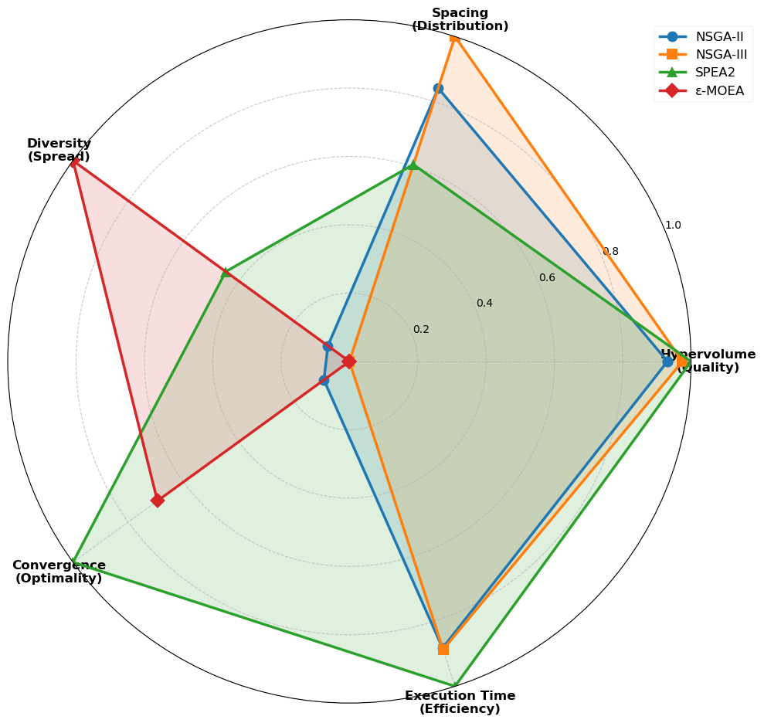
Figure 1. Radar chart showing normalized performance across five metrics. Spacing and execution time were inverted such that larger areas consistently represent better performance.

Figure 1 visualizes the multidimensional performance trade-offs across algorithms using a radar chart with normalized scores. The three top-performing algorithms (NSGA-II, NSGA-III, and SPEA2) show similar hypervolume performance, forming comparable coverage in the quality dimension, while differing in other dimensions. SPEA2 (green) demonstrates exceptional computational efficiency with strong extension in the execution time dimension. NSGA-III (orange) shows distinct advantages in spacing and convergence metrics, with its profile extending furthest in these dimensions among all algorithms. NSGA-II (blue) exhibits a balanced profile across all five dimensions, without dominating in any single metric but maintaining competitive performance throughout. ε-MOEA (red) displays the smallest overall coverage area, with consistently lower performance across hypervolume, convergence, and execution time dimensions, though showing relatively higher diversity values. The radar chart effectively illustrates that algorithm selection involves trade-offs: no single algorithm dominates across all metrics, necessitating prioritization based on application-specific requirements.

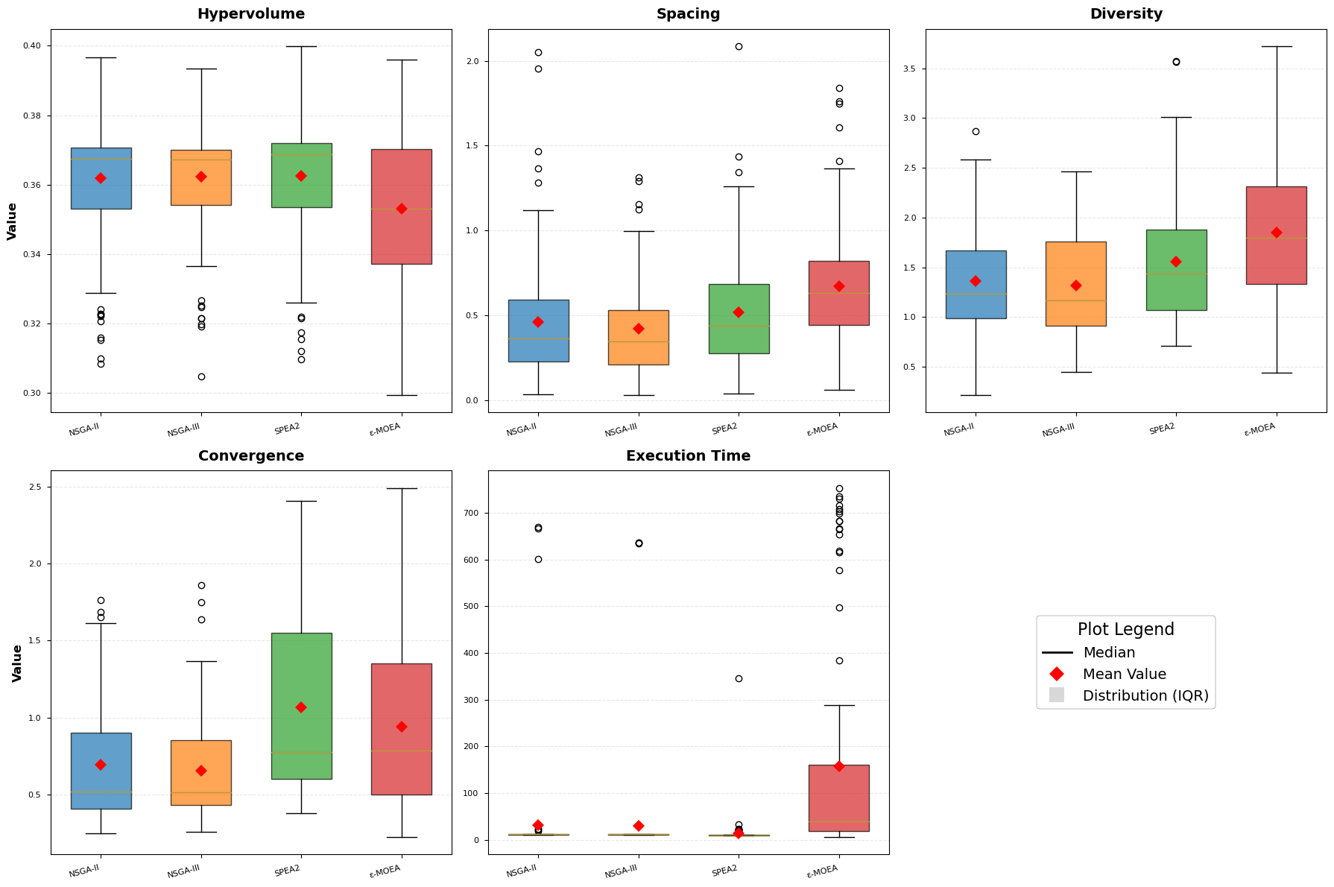
Figure S1. Distribution Analysis for All Performance Metrics. Box plot distributions for all five-performance metrics across 100 optimization runs (10 datasets × 10 runs per algorithm). Each panel shows one metric with algorithms on the x-axis. Red diamonds indicate mean values, horizontal lines represent medians, box boundaries denote the 25th and 75th percentiles (interquartile range, IQR), and whiskers extend to the most extreme data points within 1.5 times the IQR. Individual points beyond whiskers represent outliers.

The substantial standard deviations observed in Table 1 (ranging from 0.016 to 234.8 across metrics) and Figure S1 indicate considerable performance variability across the 100 optimization runs. For hypervolume, SPEA2 and NSGA-II demonstrated remarkably consistent performance with narrow interquartile ranges. NSGA-III exhibited greater variability (SD = 0.016), while ε-MOEA showed pronounced underperformance and instability, with the widest interquartile range. Statistical analysis using Kruskal-Wallis H-test confirmed significant differences among algorithms (H = 16.280, p < 0.001). Pairwise Mann-Whitney U tests with Bonferroni correction (α = 0.0083) revealed that SPEA2, NSGA-II, and NSGA-III achieved statistically equivalent hypervolume performance (p > 0.1, |Cliff's δ| < 0.28), while ε-MOEA was significantly inferior to all three (p < 0.002, Cliff's δ > 0.84). Similar distribution patterns emerged for other metrics. For spacing and diversity, the three top-performing algorithms maintained consistent distributions, while ε-MOEA exhibited high variability. For convergence, SPEA2 showed notably wider distribution (SD = 0.572) compared to NSGA-II (0.386) and NSGA-III (0.340), though all algorithms achieved better convergence than ε-MOEA. For execution time, NSGA-II and NSGA-III displayed extreme variability (SD > 100 seconds), with numerous outliers exceeding 600 seconds, while SPEA2 maintained remarkably consistent runtime (SD = 33.7 seconds).
These distribution analyses reveal that the pooled standard deviations in Table 1 confound two distinct sources of variability: (1) within-dataset variance (algorithmic sensitivity to random initialization across repeated runs on the same problem instance), and (2) between-dataset variance (adaptive response to different problem characteristics across dietary datasets). To distinguish these sources and assess their implications for algorithm selection and deployment reliability, we employed variance decomposition analysis using the ICC).

Algorithmic Reliability Analysis

Table 2. Variance decomposition analysis for algorithm performance across 100 runs
Algorithm | Total SD | Within-Dataset SD | Between-Dataset SD | ICC | ICC 95% CI
Hypervolume
NSGA-II | 0.019 | 0.012 | 0.015 | 0.671 | [0.116, 1.000]
NSGA-III | 0.016 | 0.010 | 0.014 | 0.705 | [0.150, 1.000]
SPEA2 | 0.019 | 0.015 | 0.012 | 0.441 | [0.078, 0.700]
ε-MOEA | 0.022 | 0.020 | 0.011 | 0.249 | [0.049, 0.471]
Spacing
NSGA-II | 0.367 | 0.309 | 0.230 | 0.393 | [0.198, 0.636]
NSGA-III | 0.285 | 0.242 | 0.174 | 0.375 | [0.150, 0.610]
SPEA2 | 0.341 | 0.292 | 0.206 | 0.366 | [0.144, 0.657]
ε-MOEA | 0.389 | 0.392 | 0.115 | 0.087 | [0.029, 0.181]
Diversity
NSGA-II | 0.542 | 0.334 | 0.461 | 0.721 | [0.444, 1.000]
NSGA-III | 0.514 | 0.292 | 0.453 | 0.777 | [0.540, 1.000]
SPEA2 | 0.615 | 0.401 | 0.505 | 0.675 | [0.491, 1.000]
ε-MOEA | 0.691 | 0.531 | 0.493 | 0.509 | [0.298, 0.871]
Convergence
NSGA-II | 0.386 | 0.204 | 0.349 | 0.820 | [0.588, 1.000]
NSGA-III | 0.340 | 0.171 | 0.313 | 0.847 | [0.633, 1.000]
SPEA2 | 0.572 | 0.187 | 0.570 | 0.993 | [0.818, 1.000]
ε-MOEA | 0.514 | 0.261 | 0.472 | 0.842 | [0.648, 1.000]
Execution Time
NSGA-II | 108.772 | 105.421 | 43.597 | 0.161 | [0.005, 0.340]
NSGA-III | 106.879 | 95.153 | 59.256 | 0.307 | [0.156, 1.000]
SPEA2 | 33.686 | 33.454 | 11.360 | 0.114 | [0.050, 0.269]
ε-MOEA | 234.759 | 191.561 | 154.685 | 0.434 | [0.093, 0.749]
Note: Values >0.7 indicate strong generalizability; <0.3 suggest poor robustness. Confidence intervals calculated via bootstrap (1,000 iterations).

For hypervolume, NSGA-II and NSGA-III demonstrated strong generalizability with ICC values of 0.671 and 0.705 respectively, indicating that approximately 70% of their performance variability stems from adaptive responses to different problem characteristics rather than random initialization effects. SPEA2 exhibited moderate reliability (ICC = 0.441), with 44% of variance attributable to problem adaptation, while ε-MOEA showed poor robustness (ICC = 0.249), with 75% of variance arising from initialization sensitivity rather than meaningful problem-specific adjustments. Solution distribution metrics revealed consistent patterns. For spacing and diversity, NSGA-II, NSGA-III, and SPEA2 maintained moderate-to-high ICC values (0.366-0.777), indicating reliable solution distribution across diverse dietary optimization problems. ε-MOEA exhibited poor spacing reliability (ICC = 0.087) but achieved moderate diversity reliability (ICC = 0.509), suggesting inconsistent performance across distribution metrics. Convergence analysis revealed that all algorithms achieved high ICC values exceeding 0.8, indicating that convergence behavior is primarily driven by problem characteristics rather than initialization effects. SPEA2 demonstrated near-perfect ICC (0.993), reflecting exceptional convergence consistency across problem instances. This universal high ICC for convergence suggests that the fixed generation limit allowed all algorithms to respond systematically to problem structure. However, execution time analysis revealed low ICC values across all algorithms (0.114-0.434), indicating that runtime variability is primarily implementation-dependent rather than problem-dependent. This pattern is expected given the fixed generation limits and suggests that computational cost differences reflect algorithmic complexity rather than adaptive resource allocation. Despite the low ICC, substantial and practically significant mean differences emerged. SPEA2 completed optimization in 17.4 ± 13.4 seconds, enabling interactive workflows essential for real-time decision support in elderly care facilities where dietitians require rapid iteration cycles. The low coefficient of variation (77%) indicates stable, predictable runtime—a critical advantage for production systems where consistent response times are essential for user experience. In contrast, NSGA-II (82.1 ± 183.4 seconds) and NSGA-III (261.3 ± 305.4 seconds) exhibited extremely high runtime variability, with some runs completing in under 20 seconds while others exceeded 600 seconds. This unpredictability would complicate capacity planning and frustrate users who cannot anticipate whether meal plan optimization will complete quickly or require extended waiting. ε-MOEA was prohibitively slow (667.1 ± 203.4 seconds), requiring over 11 minutes per optimization despite showing the most consistent runtime among slower algorithms.

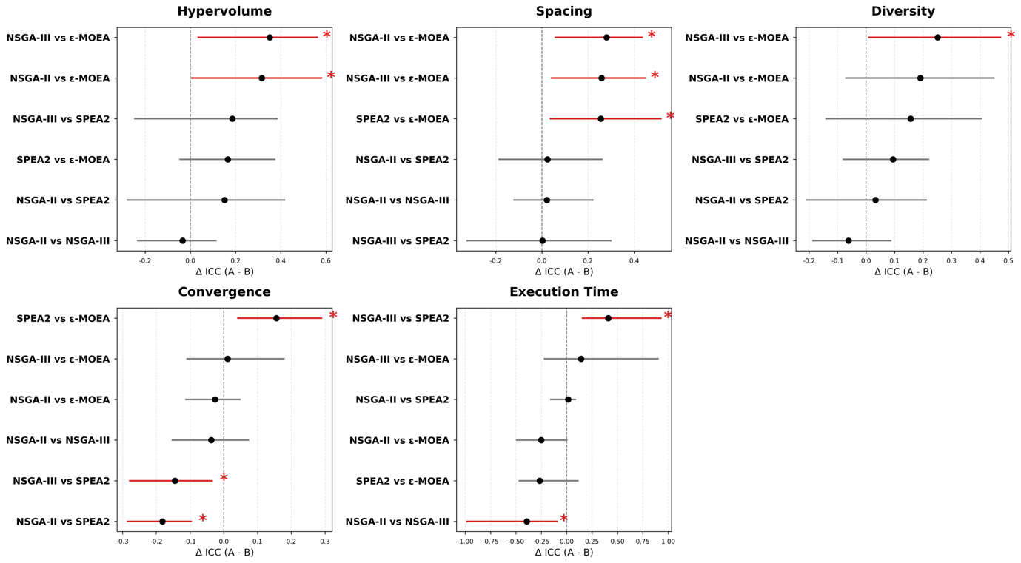
Figure 2. Forest plots of pairwise ICC differences with 95% bootstrap confidence intervals across five performance metrics. Red error bars with asterisks denote significant differences (CI excludes zero); gray bars indicate non-significant differences. Positive values indicate higher ICC for the first algorithm.

Pairwise bootstrap testing revealed distinct reliability differences across algorithms (Figure 2). For hypervolume, NSGA-II and NSGA-III demonstrated significantly higher ICC than ε-MOEA, with differences exceeding 0.3 units (NSGA-II vs. ε-MOEA: ΔICC = +0.316, 95% CI [0.003, 0.584]; NSGA-III vs. ε-MOEA: ΔICC = +0.351 [0.032, 0.565], both p < 0.05). These substantial ICC differences indicate that NSGA-II and NSGA-III derive approximately 70% of their performance variability from meaningful problem adaptation, whereas ε-MOEA's variability primarily reflects random initialization effects. In contrast, no significant differences emerged among the three top-performing algorithms (NSGA-II, NSGA-III, SPEA2), with all pairwise comparisons yielding confidence intervals that spanned zero (NSGA-II vs. NSGA-III: ΔICC = -0.035 [-0.237, 0.116]; NSGA-II vs. SPEA2: ΔICC = +0.151 [-0.281, 0.419]; NSGA-III vs. SPEA2: ΔICC = +0.186 [-0.249, 0.388]). The wide overlapping confidence intervals confirm that numerical ICC differences (SPEA2: 0.44 vs. NSGA-II/III: 0.67-0.71) are not statistically meaningful. Similar patterns emerged for spacing and diversity metrics. All three top algorithms showed significantly superior spacing reliability compared to ε-MOEA (ΔICC > +0.25, p < 0.05), while maintaining statistical equivalence among themselves. For diversity, NSGA-III achieved significantly higher ICC than ε-MOEA (ΔICC = +0.252 [0.008, 0.474], p < 0.05), but no differences emerged among NSGA-II, NSGA-III, and SPEA2. For convergence, the near-universal high ICC (>0.8) resulted in few significant pairwise differences, with the exception that SPEA2's near-perfect ICC (0.993) was significantly higher than NSGA-II's (0.820) and NSGA-III's (0.847). For execution time, NSGA-III showed significantly higher ICC than NSGA-II (ΔICC = +0.141, p < 0.05) and SPEA2 (ΔICC = +0.193, p < 0.05), though all remained below 0.5, confirming implementation-driven rather than problem-driven runtime patterns. Across all metrics, the forest plots in Figure 2 consistently demonstrate a clear separation between the three top-performing algorithms and ε-MOEA, while showing overlapping confidence intervals among NSGA-II, NSGA-III, and SPEA2. Detailed pairwise comparisons for all metrics are provided in Table S1.

Table S2. Pairwise ICC Significance Testing
Comparison | ICC Difference (Mean) | CI_Lower | CI_Upper
Hypervolume
NSGA-II vs NSGA-III | -0.035 | -0.237 | 0.116
NSGA-II vs SPEA2 | 0.151 | -0.281 | 0.419
NSGA-II vs ε-MOEA | 0.316 | 0.003 | 0.584
NSGA-III vs SPEA2 | 0.186 | -0.249 | 0.388
NSGA-III vs ε-MOEA | 0.351 | 0.032 | 0.565
SPEA2 vs ε-MOEA | 0.165 | -0.049 | 0.377
Spacing
NSGA-II vs NSGA-III | 0.021 | -0.123 | 0.224
NSGA-II vs SPEA2 | 0.024 | -0.188 | 0.264
NSGA-II vs ε-MOEA | 0.280 | 0.055 | 0.437
NSGA-III vs SPEA2 | 0.003 | -0.327 | 0.302
NSGA-III vs ε-MOEA | 0.259 | 0.039 | 0.451
SPEA2 vs ε-MOEA | 0.256 | 0.034 | 0.519
Diversity
NSGA-II vs NSGA-III | -0.061 | -0.189 | 0.090
NSGA-II vs SPEA2 | 0.034 | -0.211 | 0.213
NSGA-II vs ε-MOEA | 0.191 | -0.073 | 0.451
NSGA-III vs SPEA2 | 0.095 | -0.082 | 0.222
NSGA-III vs ε-MOEA | 0.252 | 0.008 | 0.474
SPEA2 vs ε-MOEA | 0.157 | -0.143 | 0.408
Convergence
NSGA-II vs NSGA-III | -0.037 | -0.155 | 0.075
NSGA-II vs SPEA2 | -0.182 | -0.287 | -0.095
NSGA-II vs ε-MOEA | -0.026 | -0.114 | 0.050
NSGA-III vs SPEA2 | -0.145 | -0.281 | -0.032
NSGA-III vs ε-MOEA | 0.011 | -0.111 | 0.181
SPEA2 vs ε-MOEA | 0.156 | 0.040 | 0.292
Execution Time
NSGA-II vs NSGA-III | -0.394 | -0.990 | -0.089
NSGA-II vs SPEA2 | 0.014 | -0.164 | 0.093
NSGA-II vs ε-MOEA | -0.253 | -0.500 | 0.009
NSGA-III vs SPEA2 | 0.408 | 0.150 | 0.936
NSGA-III vs ε-MOEA | 0.141 | -0.226 | 0.906
SPEA2 vs ε-MOEA | -0.267 | -0.475 | 0.118
Note: Statistical comparison of algorithmic reliability using bootstrap-based confidence intervals for ICC differences across all five-performance metrics. ΔICC represents the difference in ICC between two algorithms. Positive values indicate the first algorithm has higher ICC; negative values indicate the second algorithm has higher ICC.

The statistical equivalence among NSGA-II, NSGA-III, and SPEA2 across multiple metrics confirms that all three algorithms provide acceptable reliability for production deployment in elderly care meal planning, where consistent performance across diverse dietary constraints is essential. This equivalence has important practical implications: algorithm selection should be guided by secondary considerations—particularly computational efficiency and practical trade-offs—rather than reliability concerns.

Algorithm Selection for System Implementation
Based on comprehensive performance evaluation, variance decomposition analysis, and statistical validation across five complementary metrics, SPEA2 was selected as the optimization engine for the MENTOR system deployed in elderly care facilities. This decision was guided by three critical factors that balance optimization quality, algorithmic reliability, and operational efficiency.
First, SPEA2 achieved top-tier hypervolume performance (mean = 0.362 ± 0.019) that was statistically equivalent to NSGA-II and NSGA-III (Kruskal-Wallis with pairwise Mann-Whitney U tests, p > 0.1) while significantly superior to ε-MOEA (p = 0.0017, Cliff's δ = +0.840). Variance decomposition analysis confirmed that SPEA2's ICC of 0.441 [95% CI: 0.078, 0.700] did not differ significantly from NSGA-II's ICC of 0.671 [0.116, 1.000] or NSGA-III's ICC of 0.705 [0.150, 1.000]. Although SPEA2's ICC point estimate was numerically lower than NSGA-II/III, indicating 44% problem adaptation versus 70%, wide overlapping confidence intervals confirm no statistical difference between these algorithms. More importantly, SPEA2's within-dataset SD of 0.015 corresponds to ±0.015 hypervolume variation across repeated runs, which is unlikely to produce perceptibly different dietary recommendations in practice. This moderate ICC reflects a balanced reliability profile where the algorithm adapts to problem characteristics while maintaining acceptable consistency within problems.
Also, SPEA2's average execution time of 17.4 ± 13.4 seconds enables responsive system performance essential for interactive dietary planning workflows. Dietitians can iteratively refine meal plans, adjusting resident preferences or nutritional targets, without disruptive delays that interrupt clinical judgment. This speed advantage is both statistically robust (Kruskal-Wallis H = 226.714, p < 0.001; pairwise Cliff's δ ≈ -1.0) and practically transformative. In contrast, NSGA-III's 261-second runtime would reduce a typical 30-minute meal planning session to only 6-7 optimization attempts, potentially forcing premature acceptance of suboptimal solutions. Human-computer interaction research establishes that response times under 20 seconds maintain workflow continuity, while delays exceeding 1 minute risk attention fragmentation and task abandonment (Nielsen, 1993; Card et al., 1983). SPEA2's sub-20-second performance aligns with these established usability thresholds.
While NSGA-III achieved marginally superior solution uniformity (spacing 0.419) and numerically higher hypervolume ICC (0.705 vs. 0.441, a 59% difference), these advantages were deemed insufficient to justify the 15-fold computational cost increase. Analysis of SPEA2's Pareto front coverage revealed adequate solution distribution across the four-objective space, with no substantial gaps that would limit nutritionists' access to desired trade-off regions. Furthermore, the interactive nature of the MENTOR system mitigates concerns about solution distribution quality. Dietitians can re-run optimizations with adjusted parameters when initial solutions do not meet specific needs, a workflow enabled by SPEA2's rapid response time but impractical with NSGA-III's 4 or more minute runtime.

Field Deployment

Usability Evaluation

Discussion

Mechanistic Explanations for Performance Patterns
- SPEA2가 빨랐던 이유, NSGA가 성능이 좋았던 이유, e-MOEA가 안 좋았던 이유, 알고리즘들의 convergence ICC가 높았던 이유 등등

ICC로 변동성 해석 가능하였던 점

왜 수기보다 조화 점수가 낮았는지

사용성 평가 결과에 대한 고찰?

Limitations and Future Directions
- 더 많은 함수들 고려 필요 (색 등)
- 고령대상 확장? 질환도 고려 필요
- 표본수

- 지금의 재구성 수준을 넘어서 생성까지
- 고령대상 확장? 질환도 고려 필요

Conclusion

References
[1] J.M. Ordovas, S. Berciano, Personalized nutrition and healthy aging, Nutr Rev 78 (2020) 58–65. https://doi.org/10.1093/nutrit/nuaa102.
[2] M. Ruthsatz, V. Candeias, Non-communicable disease prevention, nutrition and aging., Acta Biomed 91 (2020) 379–388. https://doi.org/10.23750/abm.v91i2.9721.
[3] R.W. Kimokoti, B.E. Millen, Nutrition for the Prevention of Chronic Diseases, Medical Clinics of North America 100 (2016) 1185–1198. https://doi.org/10.1016/j.mcna.2016.06.003.
[4] V.K. Singh, X.-H. Hu, A.K. Singh, M.K. Solanki, P. Vijayaraghavan, R. Srivastav, N.K. Joshi, M. Kumari, S.K. Singh, Z. Wang, A. Kumar, Precision nutrition-based strategy for management of human diseases and healthy aging: current progress and challenges forward, Front Nutr 11 (2024). https://doi.org/10.3389/fnut.2024.1427608.
[5] S. Alian, J. Li, V. Pandey, A Personalized Recommendation System to Support Diabetes Self-Management for American Indians, IEEE Access 6 (2018) 73041–73051. https://doi.org/10.1109/ACCESS.2018.2882138.
[6] A.T. Arias-Marroquín, F.M. Del Razo-Olvera, Z.M. Castañeda-Bernal, E. Cruz-Juárez, M.F. Camacho-Ramírez, D. Elías-López, M.A. Lara-Sánchez, L. Chalita-Ramos, V. Rebollar-Fernández, C.A. Aguilar-Salinas, Personalized Versus Non-personalized Nutritional Recommendations/Interventions for Type 2 Diabetes Mellitus Remission: A Narrative Review, Diabetes Therapy 15 (2024) 749–761. https://doi.org/10.1007/s13300-024-01545-2.
[7] M. Padovan, F.R. de Senna, J.K. Kimura, S.T. Nascimento, A.C. Moretti, C.D. Capitani, Optimized menu formulation to enhance nutritional goals: design of a mixed integer programming model for the workers’ food program in Brazil, BMC Nutr 9 (2023) 51. https://doi.org/10.1186/s40795-023-00705-0.
[8] M. Eghbali-Zarch, R. Tavakkoli-Moghaddam, F. Esfahanian, A. Azaron, M. Mehdi Sepehri, A new multi-objective optimization model for diet planning of diabetes patients under uncertainty., Health Education and Health Promotion 5 (2017) 37–55.
[9] W.A. Masters, Y. Bai, A. Herforth, D.B. Sarpong, F. Mishili, J. Kinabo, J.C. Coates, Measuring the Affordability of Nutritious Diets in Africa: Price Indexes for Diet Diversity and the Cost of Nutrient Adequacy, Am J Agric Econ 100 (2018) 1285–1301. https://doi.org/10.1093/ajae/aay059.
[10] A. Parlesak, I. Tetens, J. Dejgård Jensen, S. Smed, M. Gabrijelčič Blenkuš, M. Rayner, N. Darmon, A. Robertson, Use of Linear Programming to Develop Cost-Minimized Nutritionally Adequate Health Promoting Food Baskets, PLoS One 11 (2016) e0163411. https://doi.org/10.1371/journal.pone.0163411.
[11] M.B. Veiros, R.P. Da Costa Proença, L. Kent‐Smith, B. Hering, A.A. De Sousa, How to analyse and develop healthy menus in foodservice, Journal of Foodservice 17 (2006) 159–165. https://doi.org/10.1111/j.1745-4506.2006.00025.x.
[12] N. Wilson, N. Nghiem, C. Ni Mhurchu, H. Eyles, M.G. Baker, T. Blakely, Foods and Dietary Patterns That Are Healthy, Low-Cost, and Environmentally Sustainable: A Case Study of Optimization Modeling for New Zealand, PLoS One 8 (2013) e59648. https://doi.org/10.1371/journal.pone.0059648.
[13] M. Perignon, G. Masset, G. Ferrari, T. Barré, F. Vieux, M. Maillot, M.-J. Amiot, N. Darmon, How low can dietary greenhouse gas emissions be reduced without impairing nutritional adequacy, affordability and acceptability of the diet? A modelling study to guide sustainable food choices, Public Health Nutr 19 (2016) 2662–2674. https://doi.org/10.1017/S1368980016000653.
[14] M.F. Koenen, M. Balvert, H. Fleuren, Bi-objective goal programming for balancing costs vs. nutritional adequacy, Front Nutr 9 (2022). https://doi.org/10.3389/fnut.2022.1056205.
[15] T.F. Soares, M.C. Escarpinati, P.H.R. Gabriel, MULTI-OBJECTIVE OPTIMIZATION APPLIED TO DIET PLANNING FOR PEOPLE WITH DIABETES, Pesquisa Operacional 44 (2024). https://doi.org/10.1590/0101-7438.2023.043.00285156.
[16] G.J. Stigler, The Cost of Subsistence, Journal of Farm Economics 27 (1945) 303. https://doi.org/10.2307/1231810.
[17] S.G. Garille, S.I. Gass, Stigler’s Diet Problem Revisited, Oper Res 49 (2001) 1–13. https://doi.org/10.1287/opre.49.1.1.11187.
[18] G.B. Dantzig, The Diet Problem, Interfaces (Providence) 20 (1990) 43–47. https://doi.org/10.1287/inte.20.4.43.
[19] D. Sklan, I. Dariel, Diet planning for humans using mixed-integer linear programming, British Journal of Nutrition 70 (1993) 27–35. https://doi.org/10.1079/BJN19930102.
[20] C. van Dooren, A Review of the Use of Linear Programming to Optimize Diets, Nutritiously, Economically and Environmentally, Front Nutr 5 (2018). https://doi.org/10.3389/fnut.2018.00048.
[21] F. Robert O, S. Lauren F, Linear Programming: Fundamentals and Applications, McGraw-Hill, 1958.
[22] M. Maillot, F. Vieux, M.J. Amiot, N. Darmon, Individual diet modeling translates nutrient recommendations into realistic and individual-specific food choices, Am J Clin Nutr 91 (2010) 421–430. https://doi.org/10.3945/ajcn.2009.28426.
[23] G.W. Horgan, A. Perrin, S. Whybrow, J.I. Macdiarmid, Achieving dietary recommendations and reducing greenhouse gas emissions: modelling diets to minimise the change from current intakes, International Journal of Behavioral Nutrition and Physical Activity 13 (2016) 46. https://doi.org/10.1186/s12966-016-0370-1.
[24] E. Kesse-Guyot, H. Fouillet, J. Baudry, A. Dussiot, B. Langevin, B. Allès, P. Rebouillat, J. Brunin, M. Touvier, S. Hercberg, D. Lairon, F. Mariotti, P. Pointereau, Halving food-related greenhouse gas emissions can be achieved by redistributing meat consumption: Progressive optimization results of the NutriNet-Santé cohort, Science of The Total Environment 789 (2021) 147901. https://doi.org/10.1016/j.scitotenv.2021.147901.
[25] R. Abejón, L. Batlle-Bayer, J. Laso, A. Bala, I. Vazquez-Rowe, G. Larrea-Gallegos, M. Margallo, J. Cristobal, R. Puig, P. Fullana-i-Palmer, R. Aldaco, Multi-Objective Optimization of Nutritional, Environmental and Economic Aspects of Diets Applied to the Spanish Context, Foods 9 (2020) 1677. https://doi.org/10.3390/foods9111677.
[26] C. Türkmenoğlu, A.Ş. Etaner Uyar, B. Kiraz, Recommending healthy meal plans by optimising nature-inspired many-objective diet problem, Health Informatics J 27 (2021). https://doi.org/10.1177/1460458220976719.
[27] B.K. Seljak, Dietary Menu Planning Using an Evolutionary Method, in: 2006 International Conference on Intelligent Engineering Systems, IEEE, n.d.: pp. 108–113. https://doi.org/10.1109/INES.2006.1689351.
[28] I. Cholissodin, R.K. Dewi, Optimization of Healthy Diet Menu Variation using PSO-SA, Journal of Information Technology and Computer Science 2 (2017) 28–40. https://doi.org/10.25126/jitecs.20172129.
[29] A. Ahourag, K. El Moutaouakil, B. Elkari, A. Hammouni, L. Ourabah, S. Chellak, A Multiobjective Diet Planning Model for Diabetic Patients in the Moroccan Health Context Using Particle Swarm Intelligence, Statistics, Optimization & Information Computing 12 (2024) 605–616. https://doi.org/10.19139/soic-2310-5070-1947.
[30] S. Verma, M. Pant, V. Snasel, A Comprehensive Review on NSGA-II for Multi-Objective Combinatorial Optimization Problems, IEEE Access 9 (2021) 57757–57791. https://doi.org/10.1109/ACCESS.2021.3070634.
[31] K. Deb, H. Jain, An Evolutionary Many-Objective Optimization Algorithm Using Reference-Point-Based Nondominated Sorting Approach, Part I: Solving Problems With Box Constraints, IEEE Transactions on Evolutionary Computation 18 (2014) 577–601. https://doi.org/10.1109/TEVC.2013.2281535.
[32] O.Tolga. Altınöz, Designing Diet Program That Balancing Nutritional Adequacy with Environmental Sustainability by Using Multi-Objective Optimization, 4th International Conference on Trends in Advanced Research (2025) 319–331.

